**Using bars, columns, and lines**

**Introduction**

Previously, you learned about different chart types in Microsoft Power BI, including line charts, various bar and column charts, as well as area and stacked area charts. These visualizations are popular for displaying data in a clear and organized way.

In this step-by-step activity, you will apply some of your newly gained knowledge by creating a comprehensive report for Adventure Works using these visualizations. Specifically, you will:

1. Import the provided sales dataset, *Using bars, columns, and lines,* provided in Step 1 below.
2. Present the February, March, and April sales trends across all regions using a line chart.
3. Display the distribution of canceled orders, shipped orders, and orders under processing individually in all regions during the quarter using a clustered column chart.
4. Display the order quantity across all regions during this time using a stacked bar chart.

**Instructions**

**Step 1: Load the dataset**

Before you begin, download the *Using bars, columns, and lines* dataset containing Adventure Works sales data for February, March, and April.

[Using bars, columns, and lines](https://d3c33hcgiwev3.cloudfront.net/m_L0disbTvu0C4fQXSIYNg_d137b7b970cf4848b0332975d63927e1_Using-bars-columns-and-lines.xlsx?Expires=1737936000&Signature=YeoYXaN8iDpdcM~lHAHVzqNEi-7jEYfUovmTzUZ6uRai7EbTJf9eXZqpkA1-I8QPLrp78g7OwfoQpv5y9fOQX~NSa8GnGGSLCOPVZlkonxI51N8ly1i4NCy99QIIZNsPo6~gOHcz-XhjsOTxe8wgg~LUjVtOg6g-Lp99lVgNnaM_&Key-Pair-Id=APKAJLTNE6QMUY6HBC5A" \t "_blank)

[XLSX File](https://d3c33hcgiwev3.cloudfront.net/m_L0disbTvu0C4fQXSIYNg_d137b7b970cf4848b0332975d63927e1_Using-bars-columns-and-lines.xlsx?Expires=1737936000&Signature=YeoYXaN8iDpdcM~lHAHVzqNEi-7jEYfUovmTzUZ6uRai7EbTJf9eXZqpkA1-I8QPLrp78g7OwfoQpv5y9fOQX~NSa8GnGGSLCOPVZlkonxI51N8ly1i4NCy99QIIZNsPo6~gOHcz-XhjsOTxe8wgg~LUjVtOg6g-Lp99lVgNnaM_&Key-Pair-Id=APKAJLTNE6QMUY6HBC5A" \t "_blank)

1. Create a new Power BI file. Import the dataset by selecting the **Import data from Excel** button.

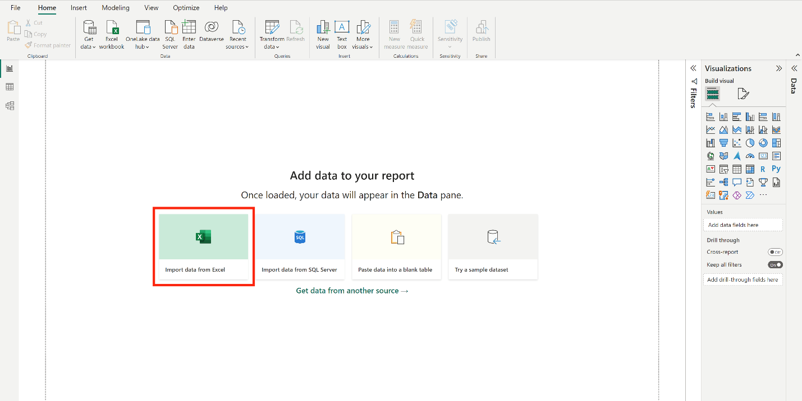

1. On the next screen, select the **File**, then *Using bars, columns, and lines.xlxs*.
2. Select **Load** on the next screen, as you don’t need to transform the dataset for this exercise.

**Step 2: Add a line chart to illustrate sales trends over time**

1. Insert a line chart in the report by selecting the **line chart** icon on the **Visualizations** pane.

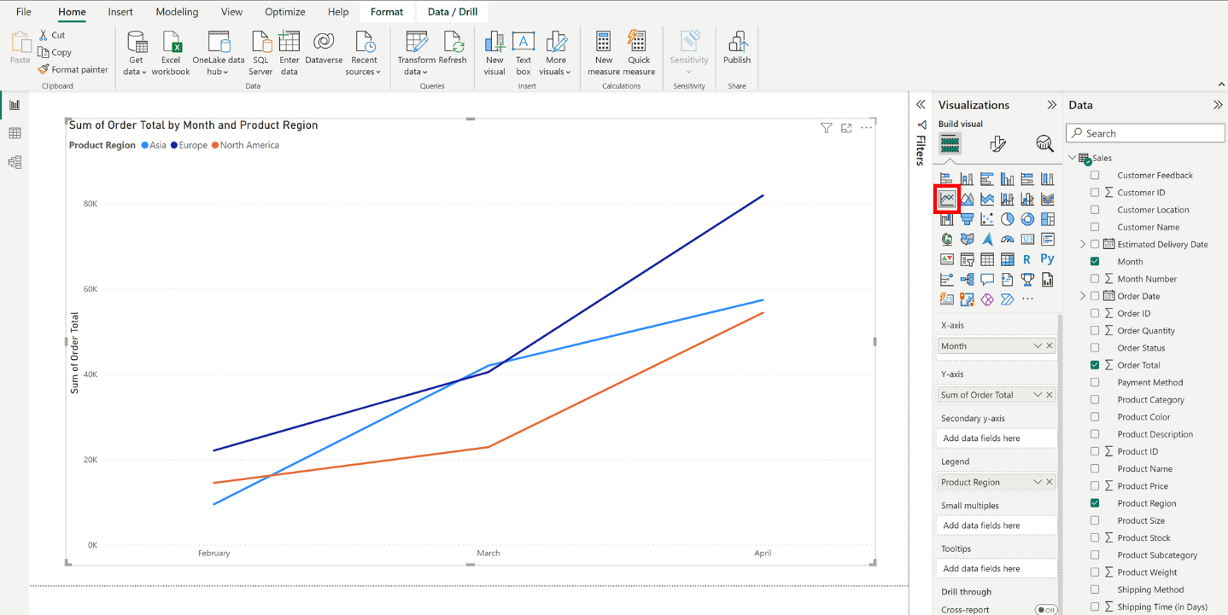

1. Select the **Month**, **Order Total**, and **Product Region** fields from the **Data** pane.

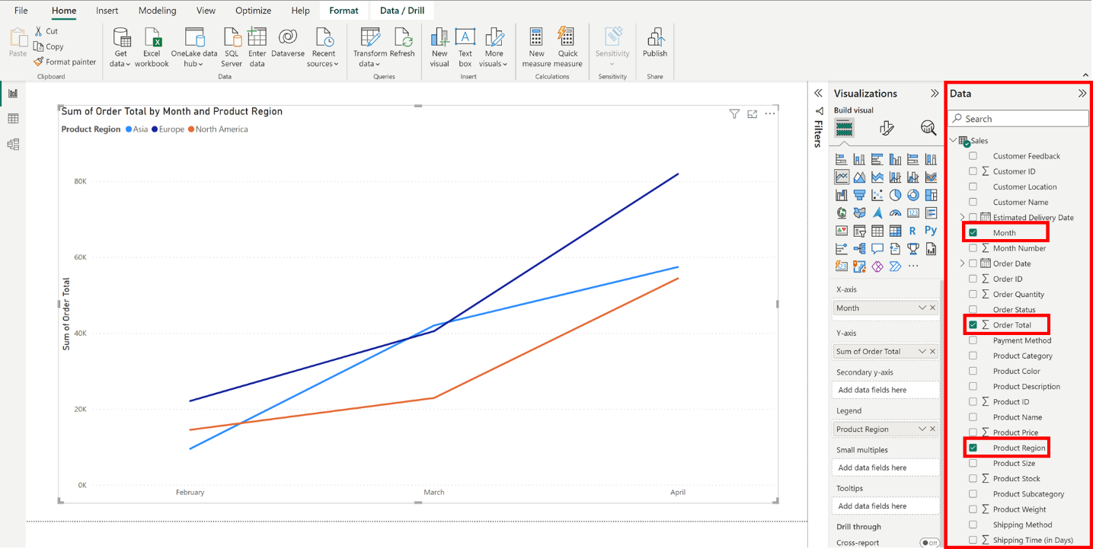

1. Ensure that the **X-axis** contains the **Month** field, the **Y-axis** contains the **Sum of Order Total** field, and the **Legend** contains the **Product Region** field.

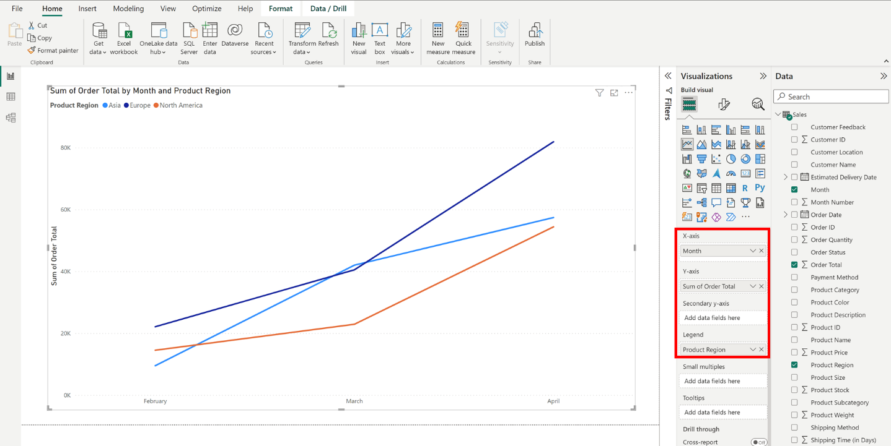

1. Resize the line chart as needed to create space for additional visuals under it.

**Step 3: Add a clustered column chart to display the distribution of order statuses**

1. Insert a clustered column chart under the line chart by selecting the **clustered column chart** icon on the **Visualizations** pane.

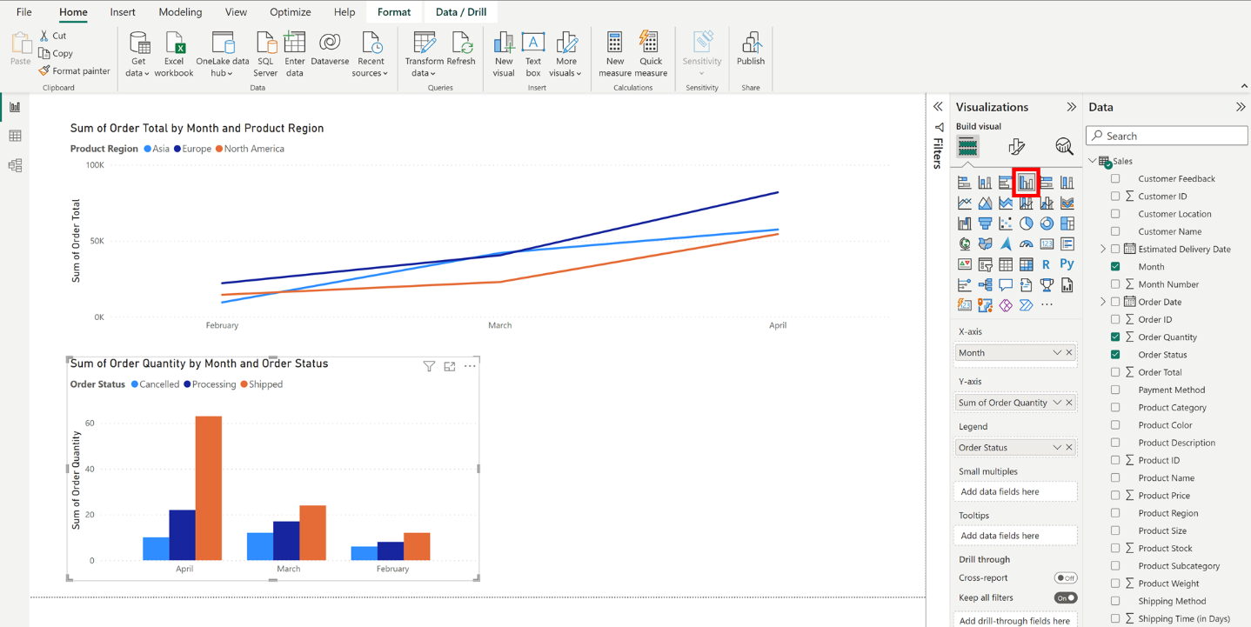

1. Select the column chart you inserted, and, from the **Data** pane, select the **Month, Order Quantity,** and **Order Status** fields for this visual.

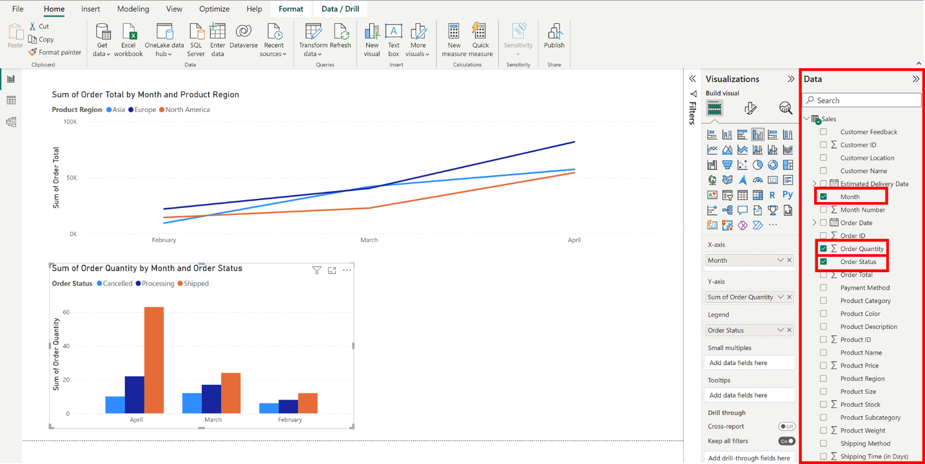

1. Ensure the **X-axis** contains the **Month** field, the **Y-axis** contains the **Sum of Order Quantity** field and the **Legend** contains the **Order Status** field.

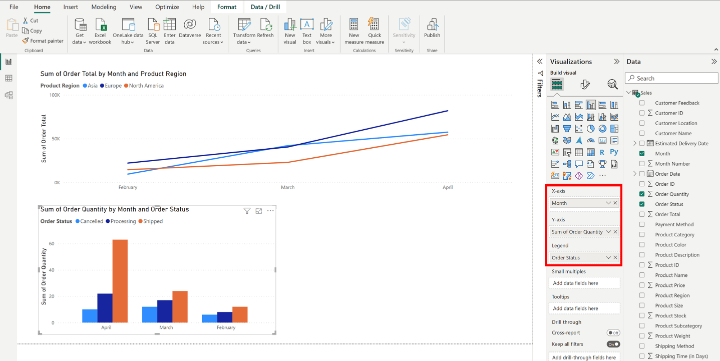

**Step 4: Add a stacked bar chart to demonstrate differences in order quantity across different regions**

1. Insert a stacked bar chart by selecting the **stacked bar chart** icon on the **Visualizations** pane. Drag this chart to the right side of the stacked column chart.

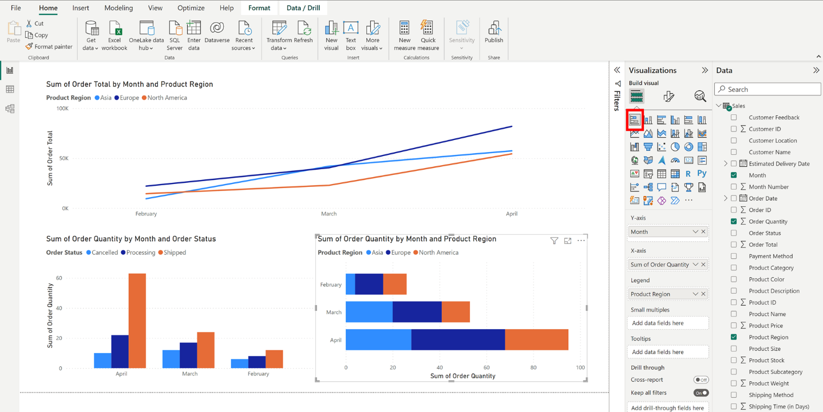

1. Select the **Month, Order Quantity,** and **Product Region** fields from the **Data** pane for this chart.

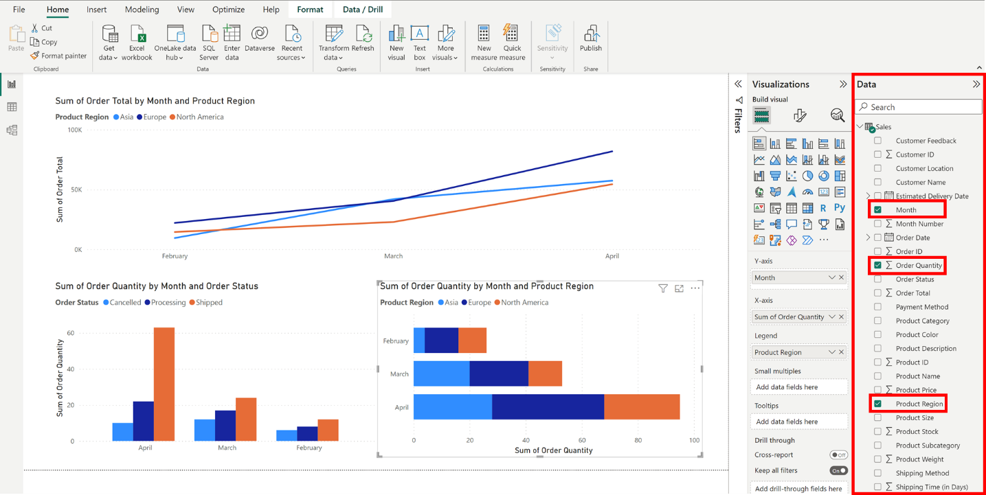

1. Ensure the **X-axis** contains the **Sum of Order Quantity** field, the **Y-axis** contains the **Month** field, and the **Legend** contains the **Product Region** field.

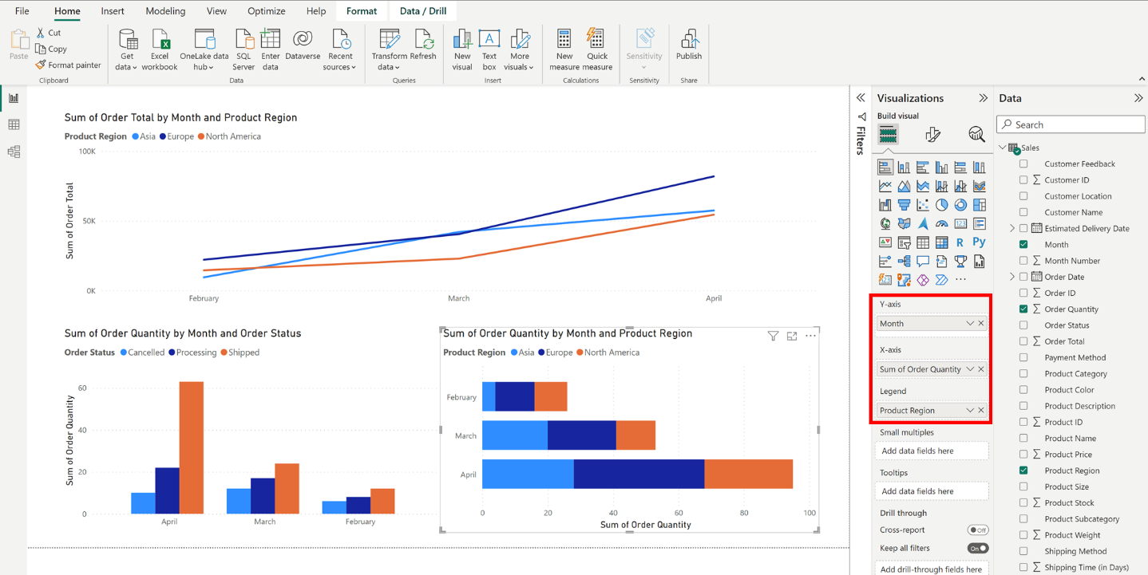

**Step 5: Save the report**

Select the **save** icon in the top left corner to save the report. You will need this file for another exercise later in this course. Your saved report should appear as follows:

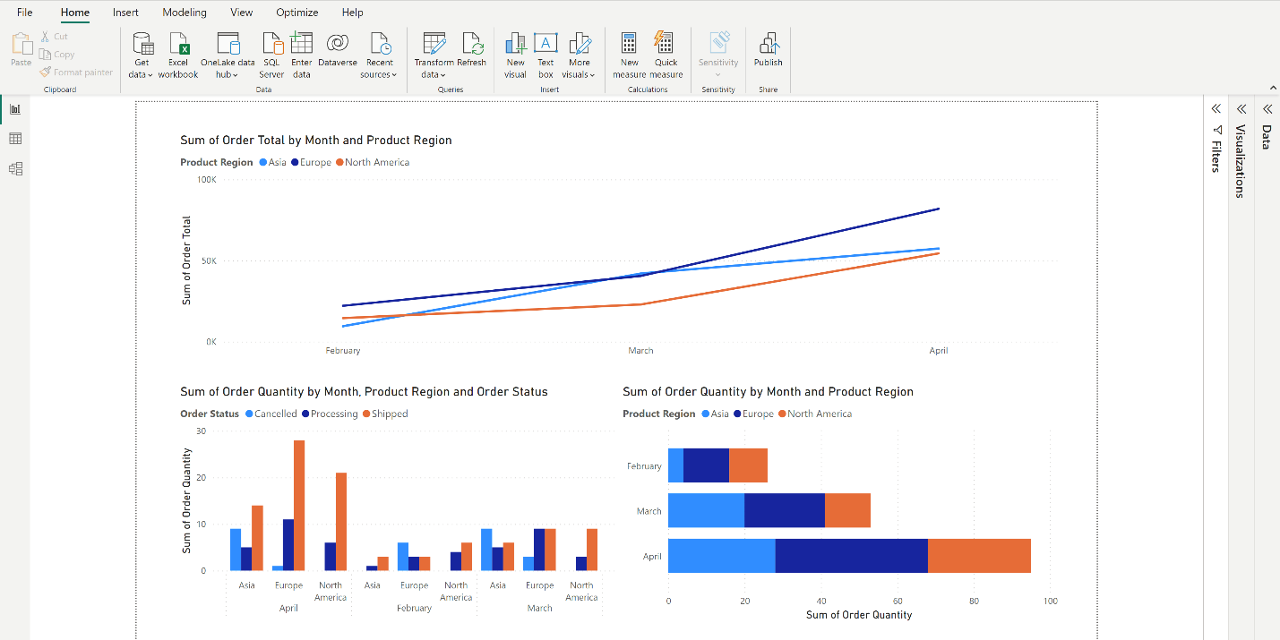

**Conclusion**

In this activity, you practiced using line, clustered column, and stacked bar charts to illustrate sales data. Stakeholders can use the line chart to understand trends over time, helping them identify patterns and make informed decisions. The clustered column chart allowed you to display the distribution of order statuses (canceled, shipped, and under processing) across regions, highlighting areas of concern or success. The stacked bar chart helped you present variations in order quantity across regions during a specific period.